Git reset

soft

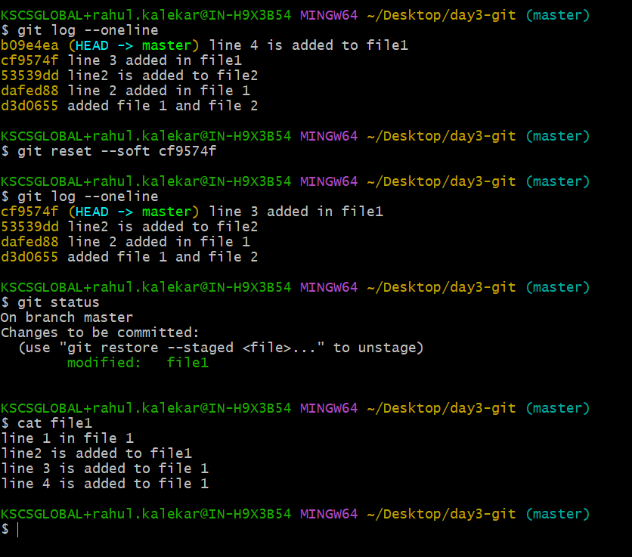

Hard ,

Deletes the changes from working directo

Mixed

Stash

But if we create another file , file 4, and don’t git add . , it does not push to stash

Git branch

